1. 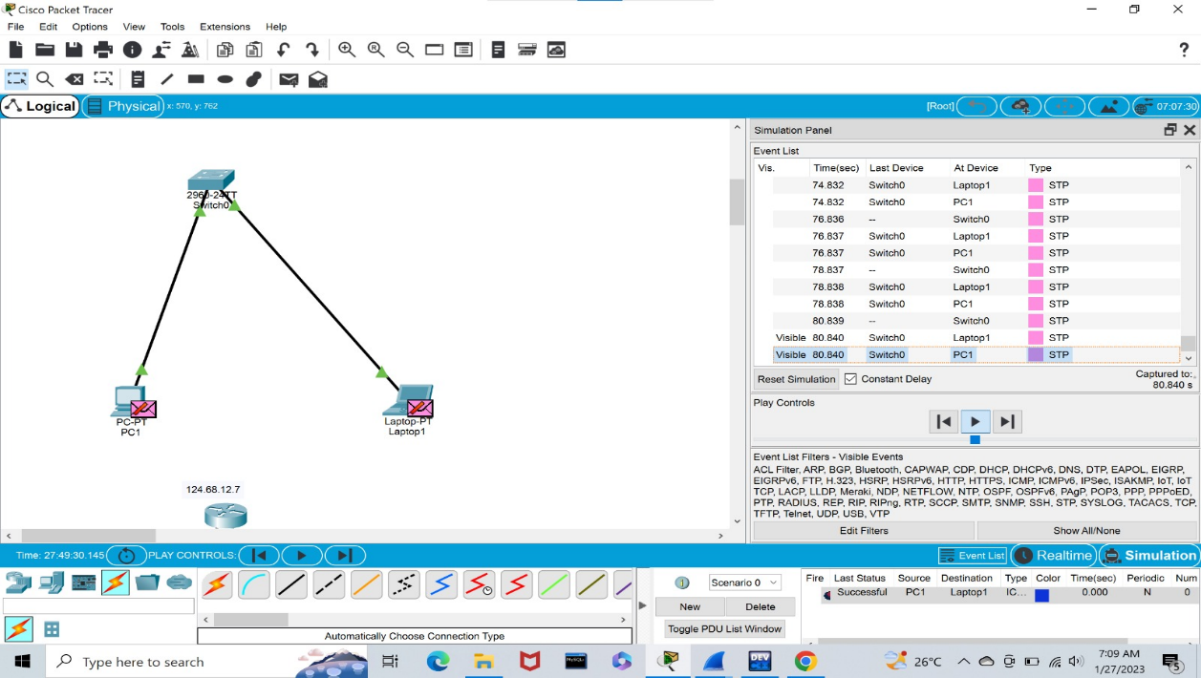Configuration of Network Devices using Packet Tracer (Hub, Switch, Ethernet, Broadcast

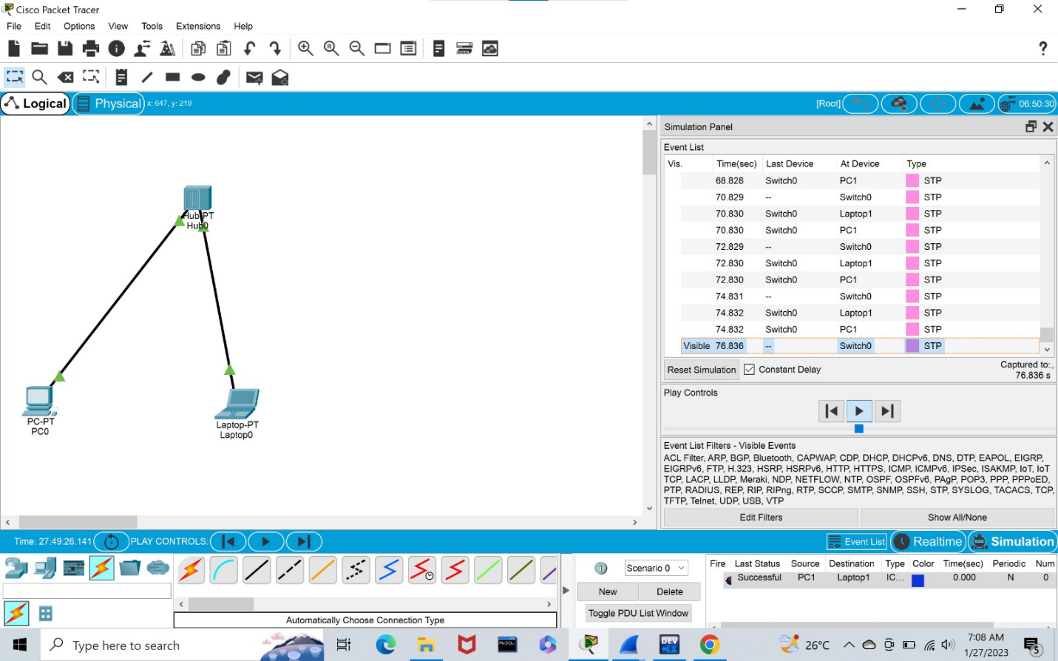

1. **Configuration of Topologies using Packet Tracer (Star, Mesh, Tree,**

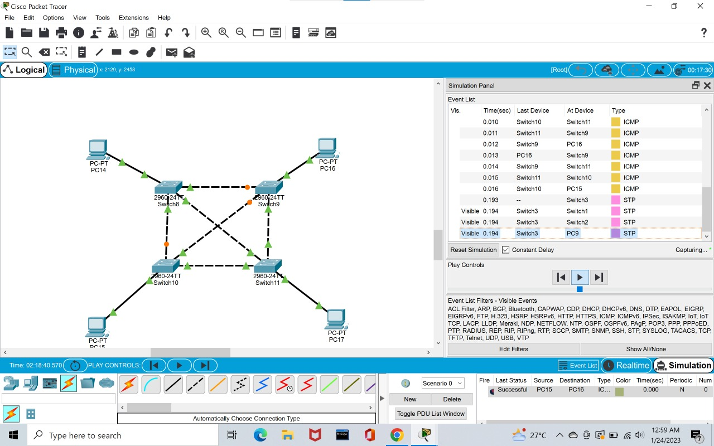

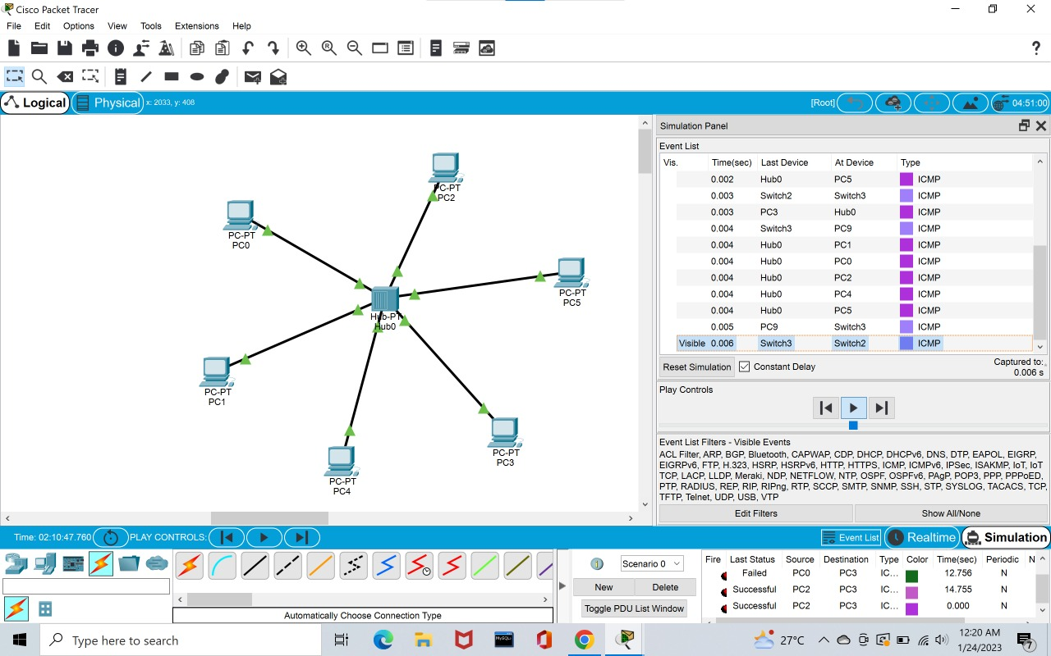

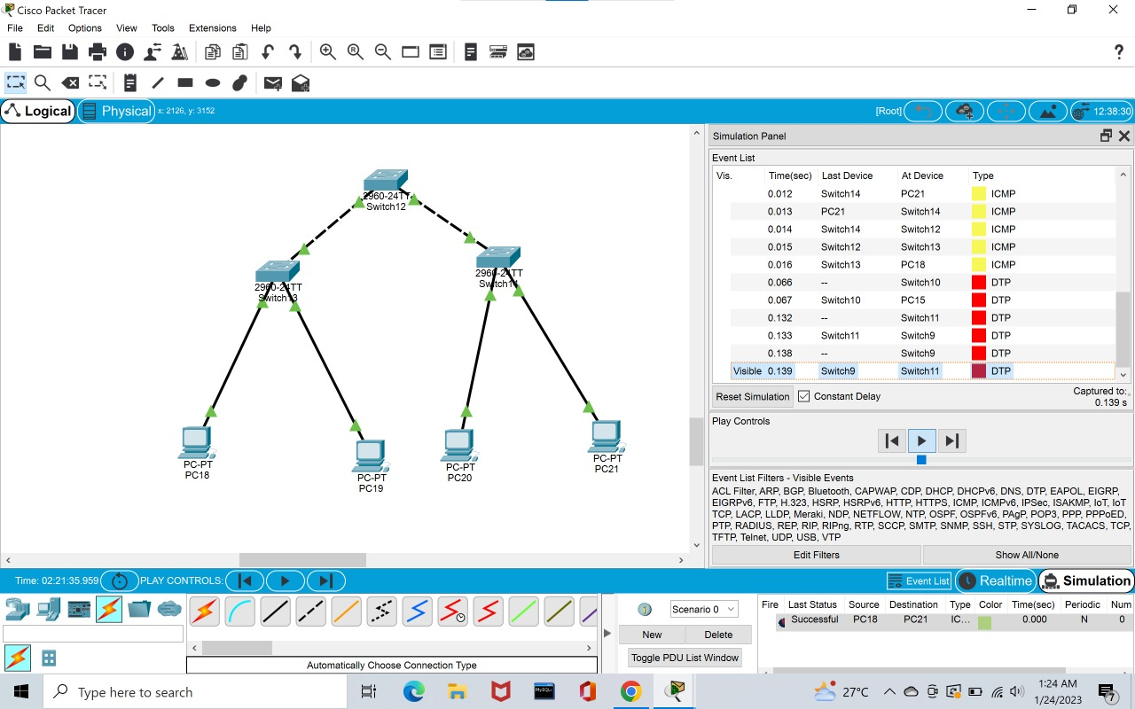

1. **Configuration of Topologies using Packet Tracer (Bus, Ring, Hybrid)**

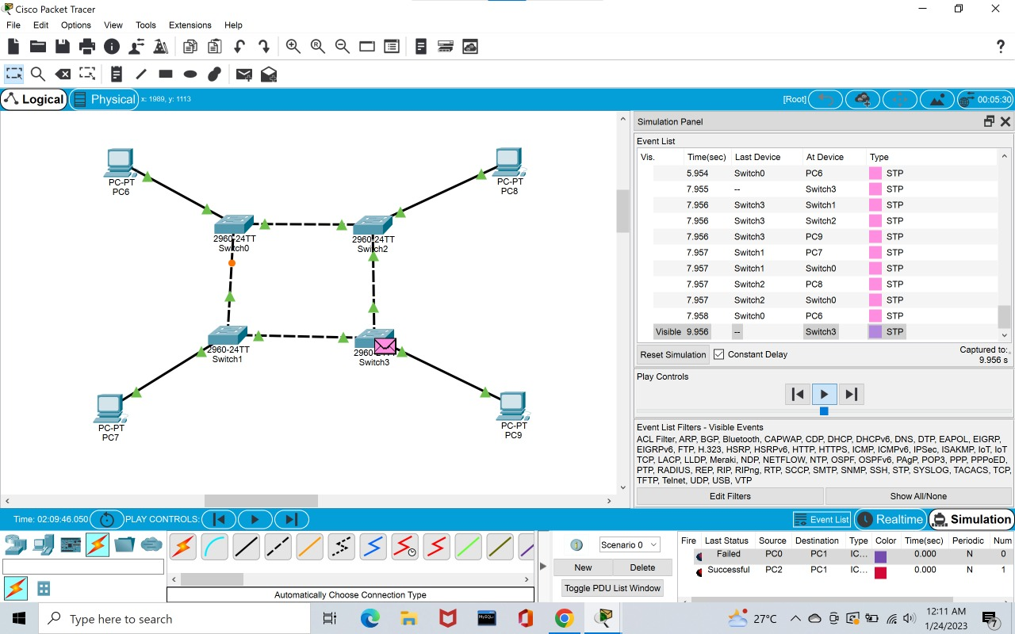

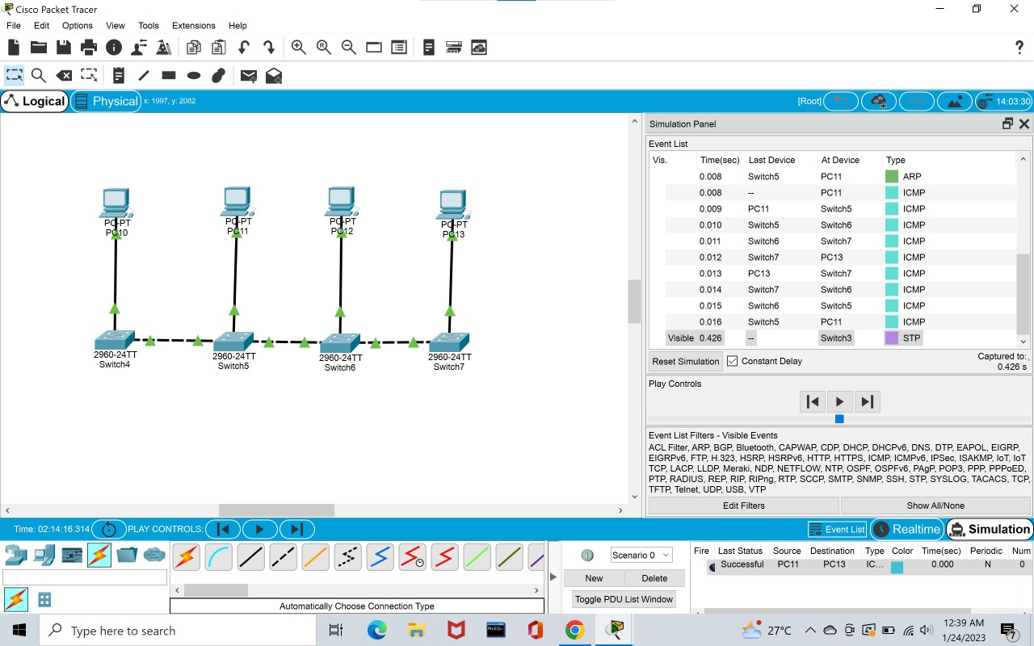

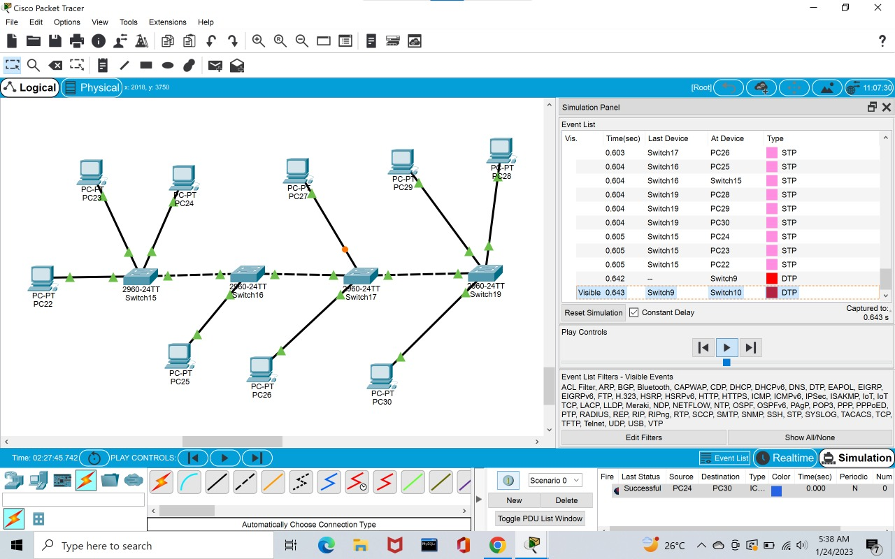

**4. Data Link Layer Traffic Simulation using Packet Tracer Analysis of CSMA/CD&amp;**

**CSMA/CA**

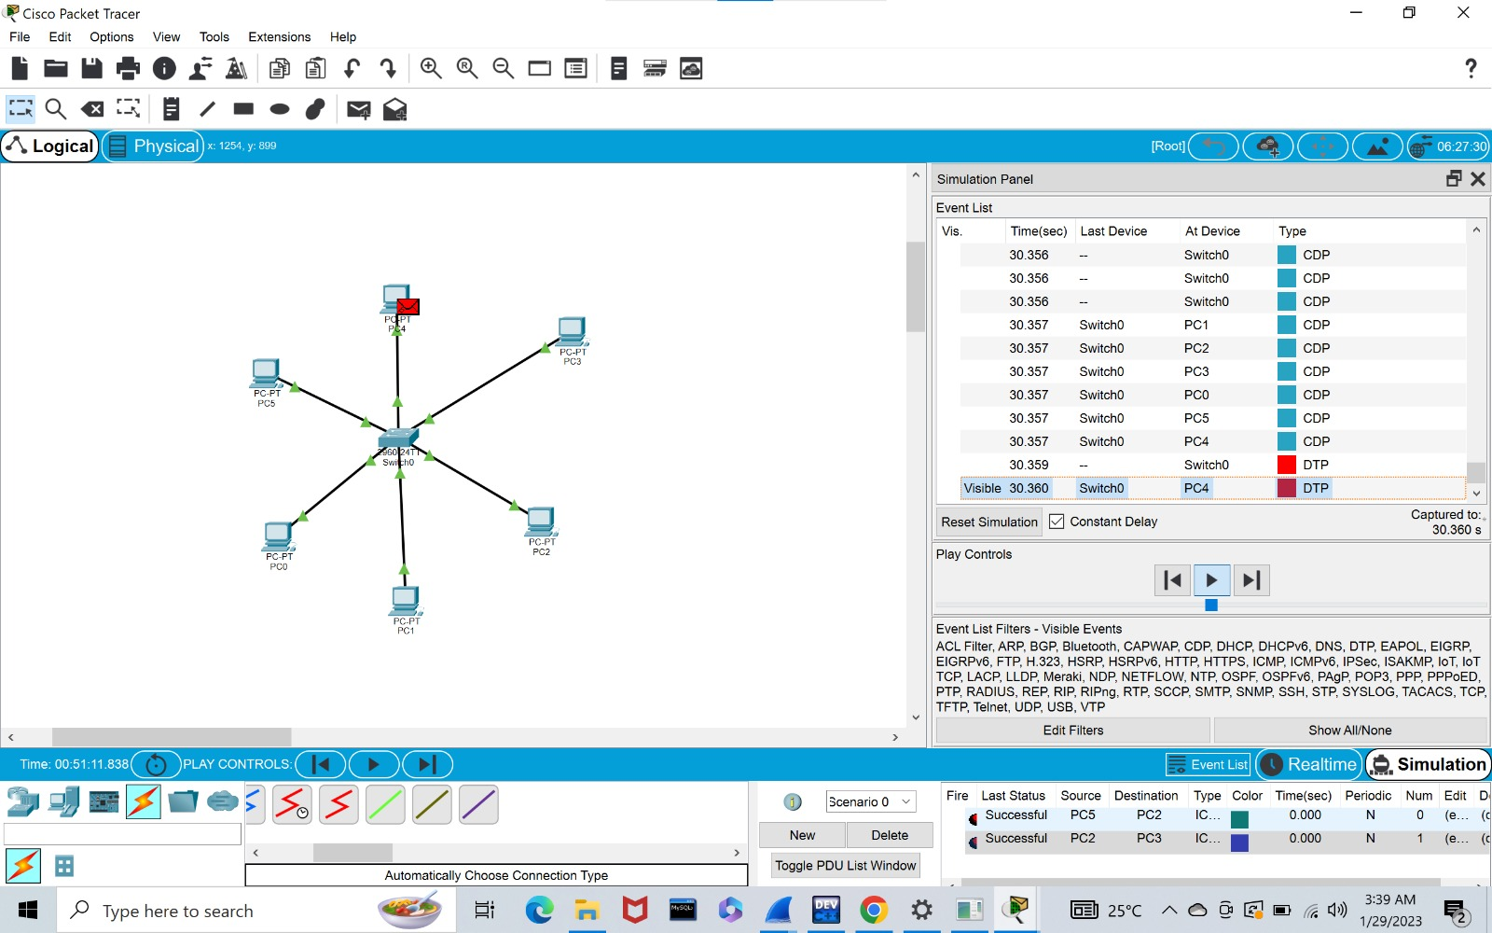

**5.Data Link Layer Traffic Simulation using Packet Tracer Analysis of ARP**

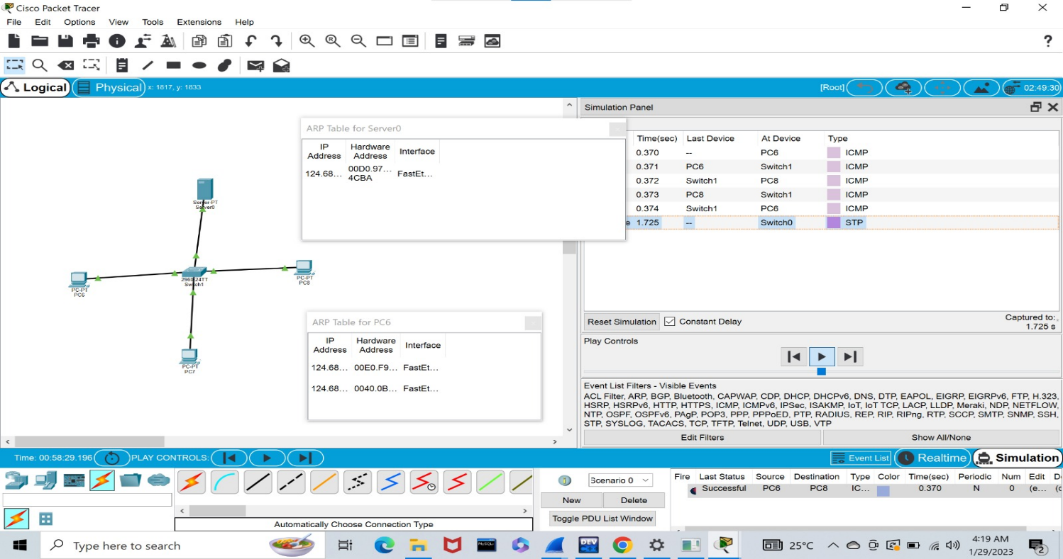

**6. Static Routing using Packet Tracer**

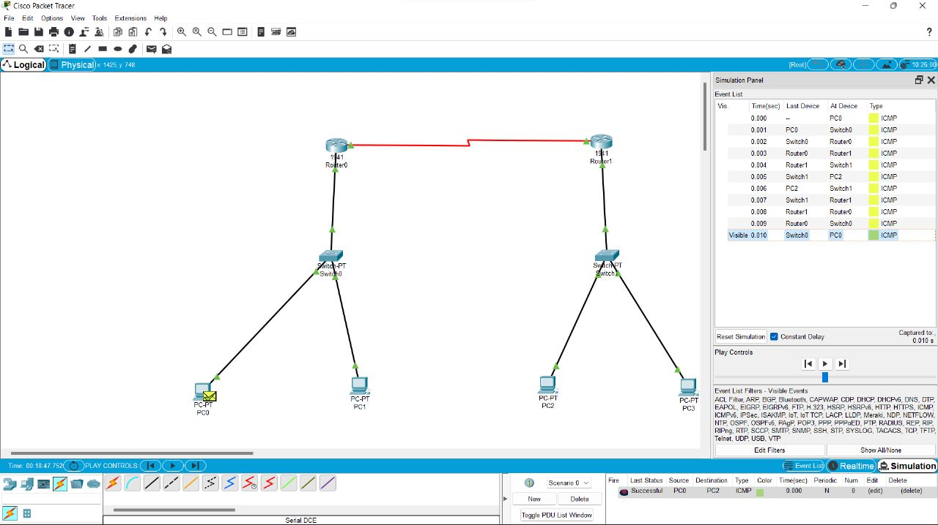

**7. Dynamic Routing using Packet Tracer ( OSPF)**

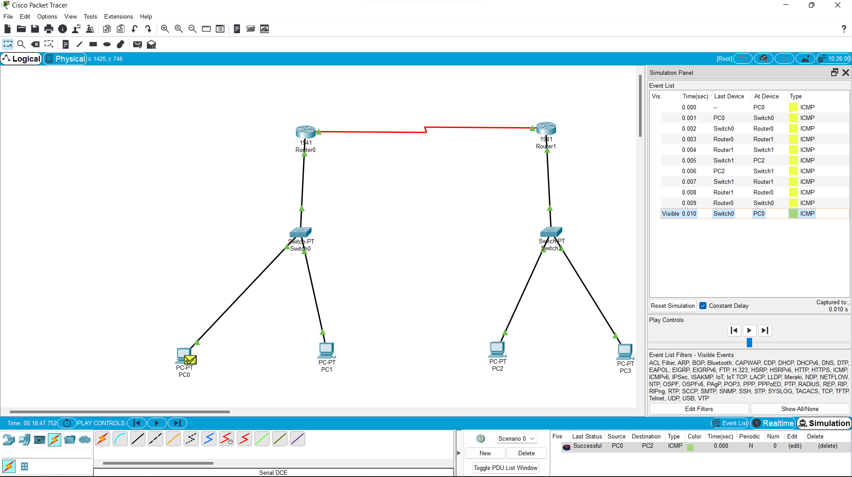

**8. Subnetting – Class C Addressing**

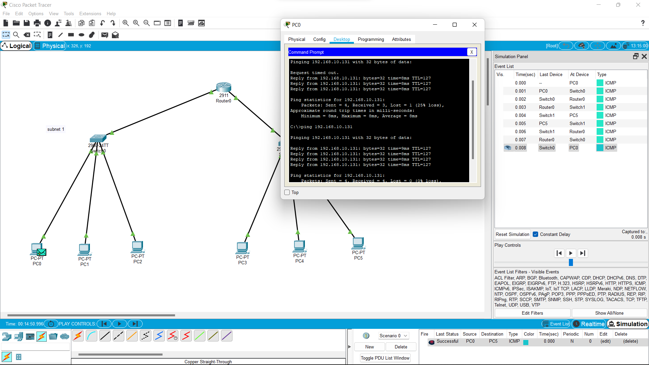

**9. Functionalities of TCP, UDP**

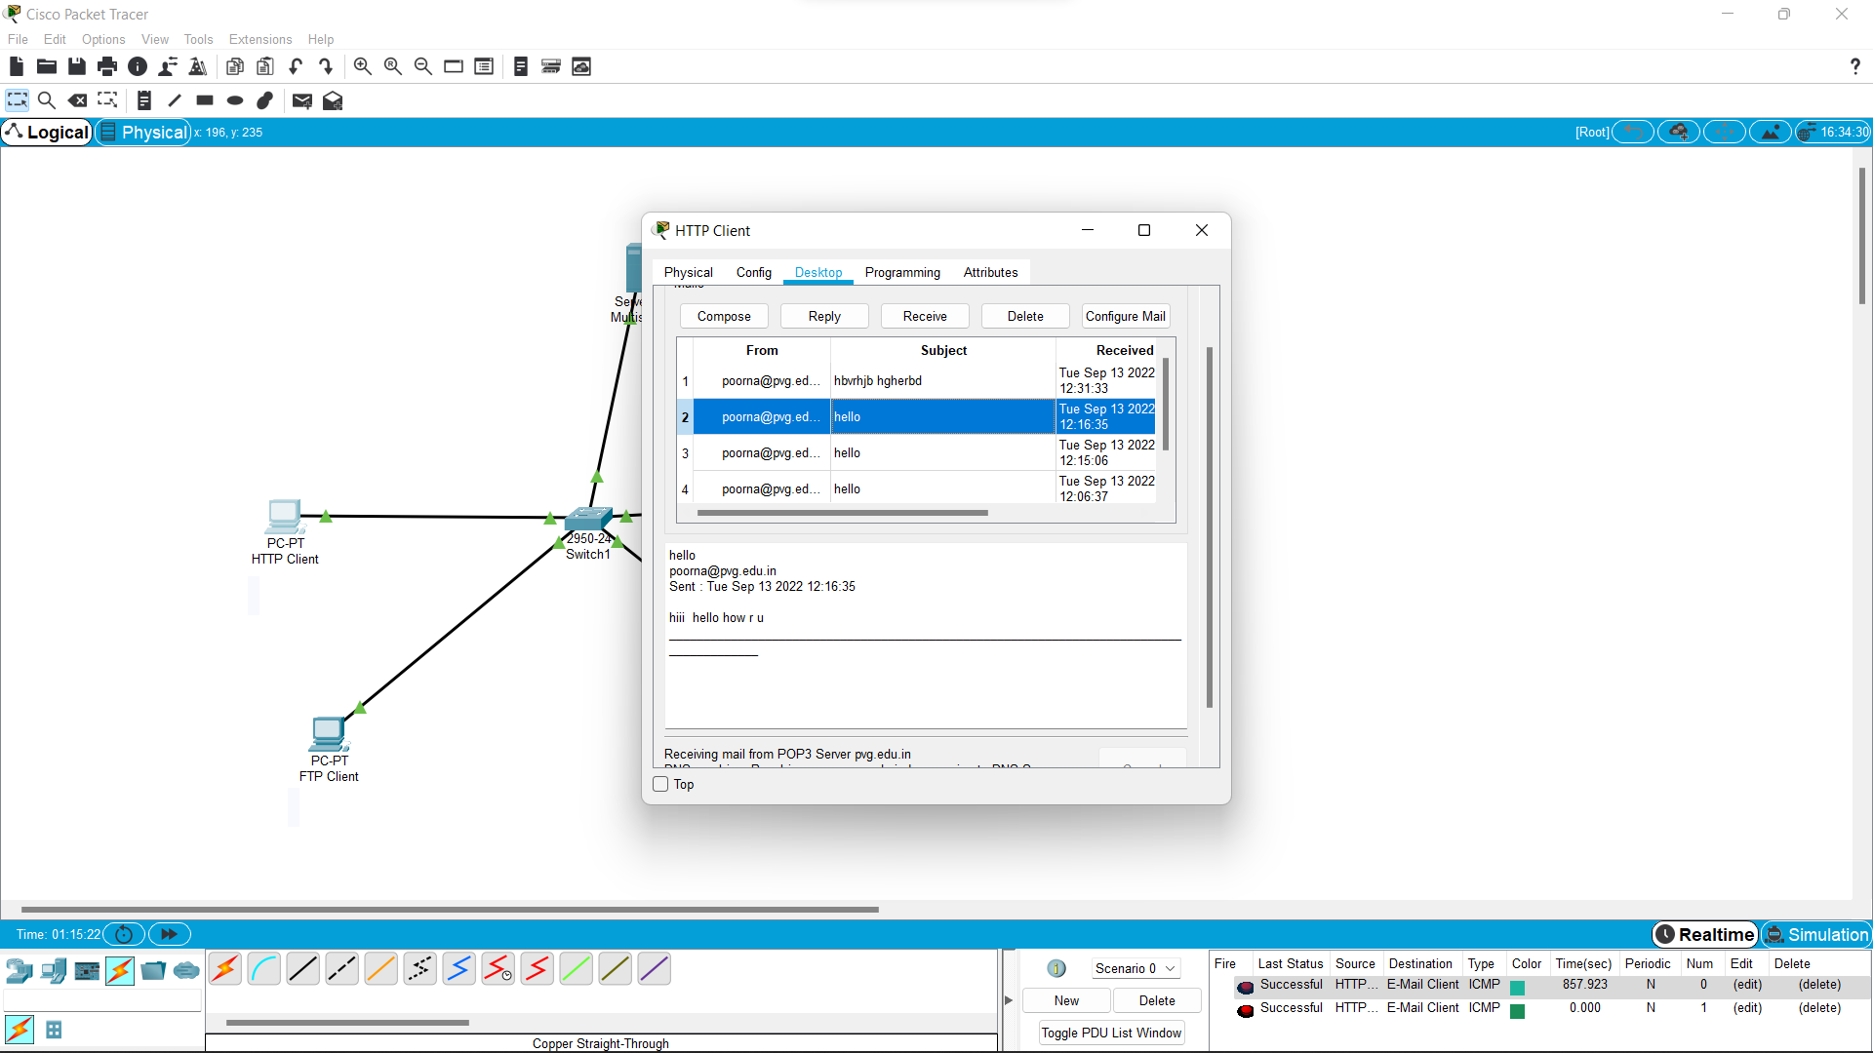

**10. IOT Based Smart Home Using Cisco Packet Tracer**

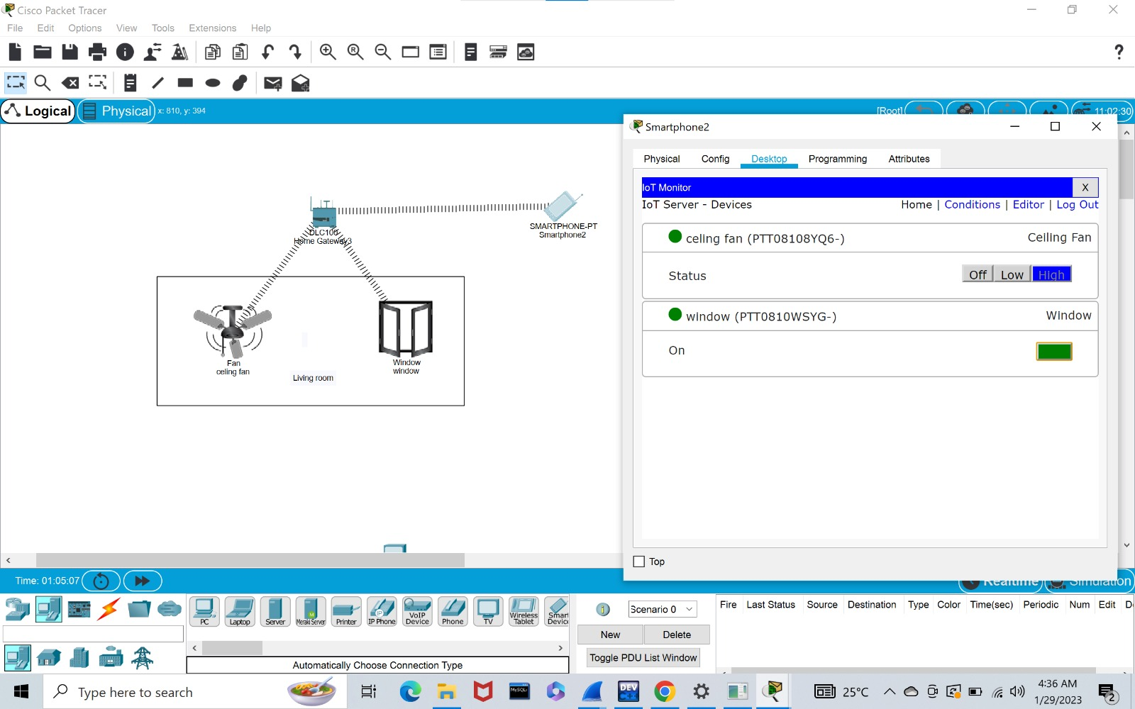

**11. Simulating X,Y,Z Company Network Design**

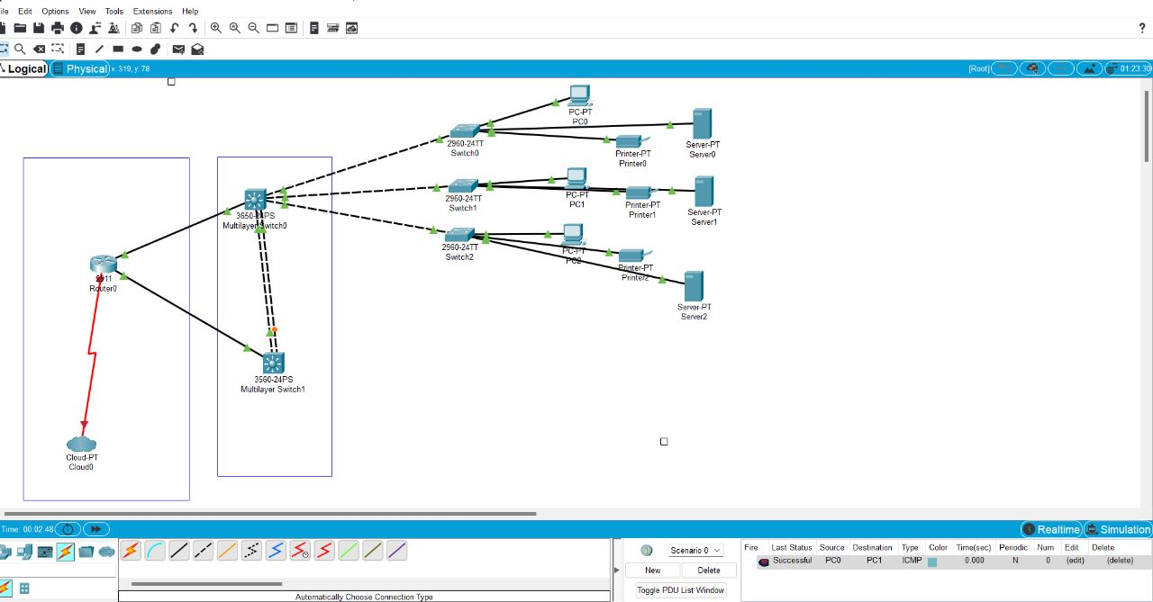

**12.wire shark(arp,http,dns,tcp)**

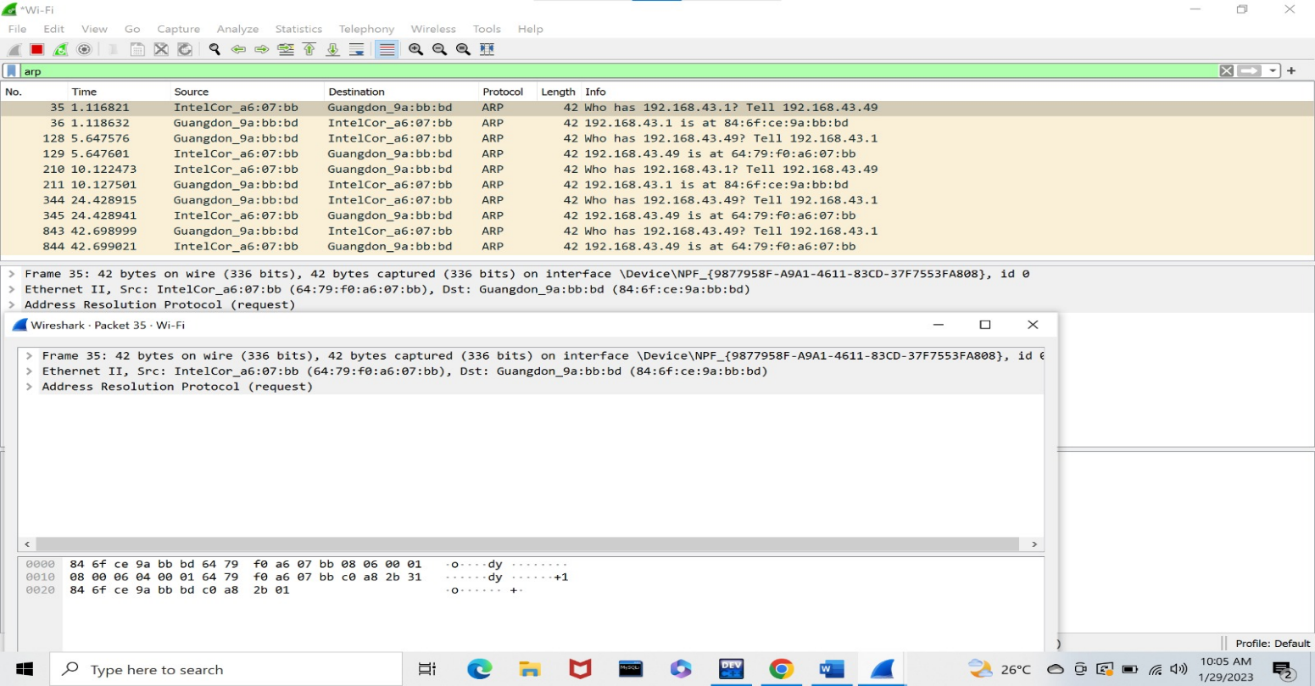

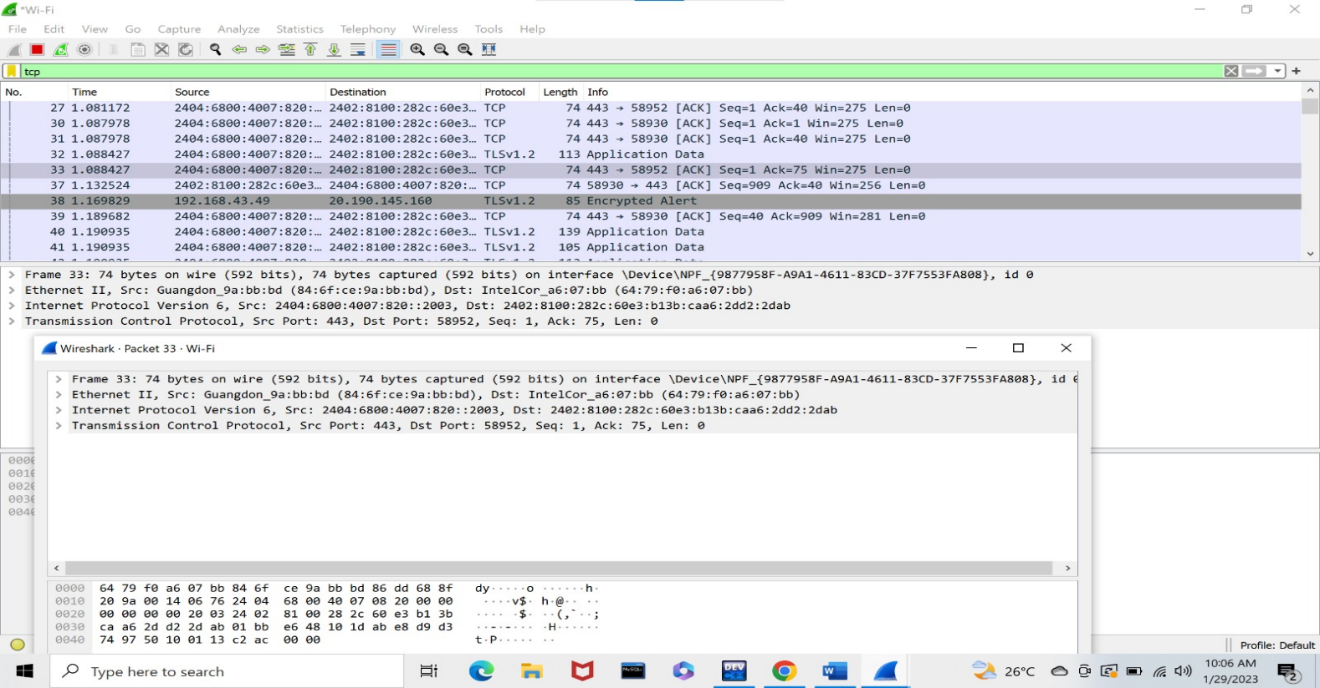

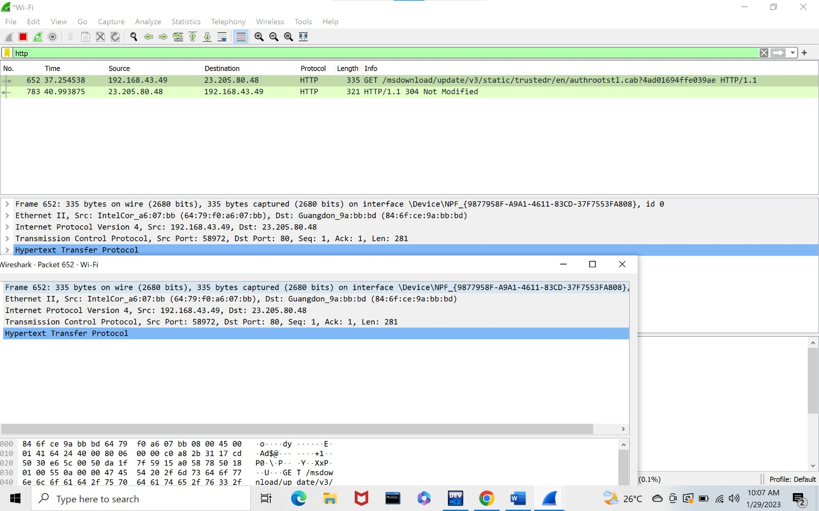

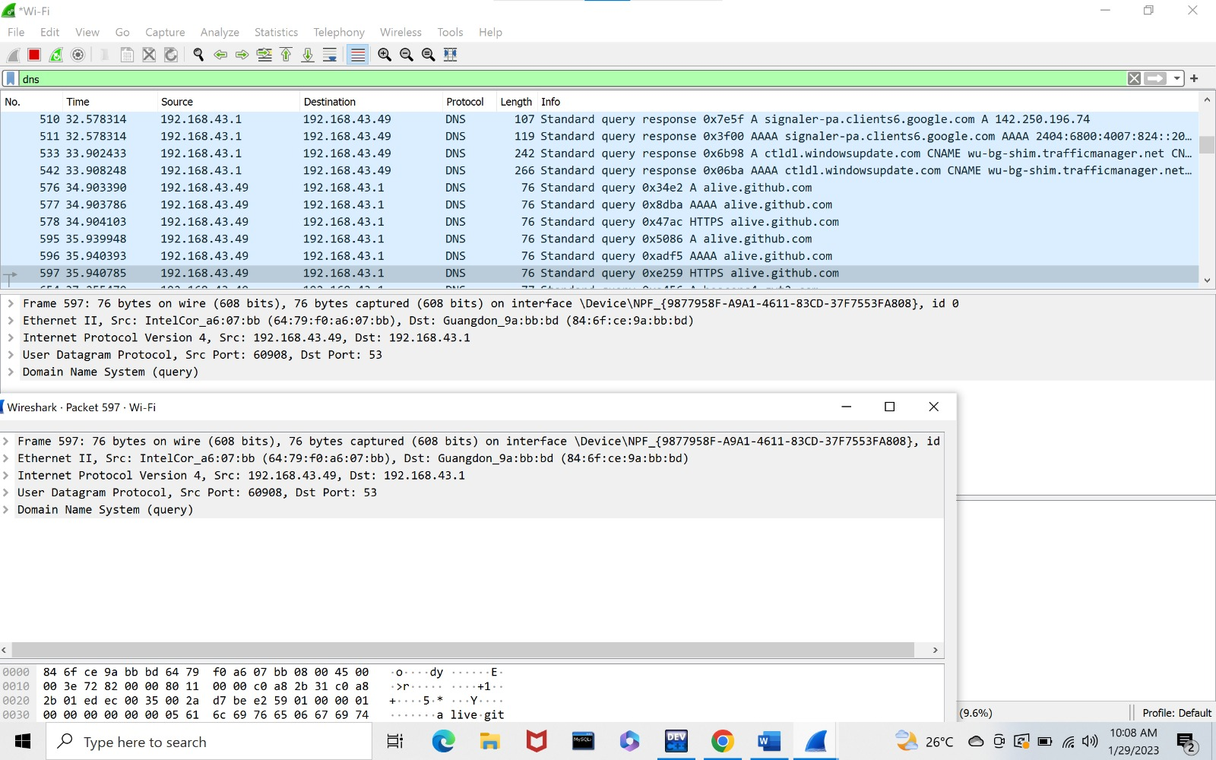

**14. Bit stuffing**

**# include<stdio.h>**

**#include<string.h>**

**int main()**

**{**

**int a[20],b[30],i,j,k,count,n;**

**printf("Enter frame size (Example: 8):");**

**scanf("%d",&n);**

**printf("Enter the frame in the form of 0 and 1 :");**

**for(i=0; i<n; i++)**

**scanf("%d",&a[i]);**

**i=0;**

**count=1;**

**j=0;**

**while(i<n)**

**{**

**if(a[i]==1)**

**{**

**b[j]=a[i];**

**for(k=i+1; a[k]==1 && k<n && count<5; k++)**

**{**

**j++;**

**b[j]=a[k];**

**count++;**

**if(count==5)**

**{**

**j++;**

**b[j]=0;**

**}**

**i=k;**

**}**

**}**

**else**

**{**

**b[j]=a[i];**

**}**

**i++;**

**j++;**

**}**

**printf("After Bit Stuffing :");**

**for(i=0; i<j; i++)**

**printf("%d",b[i]);**

**return 0;**

**}**

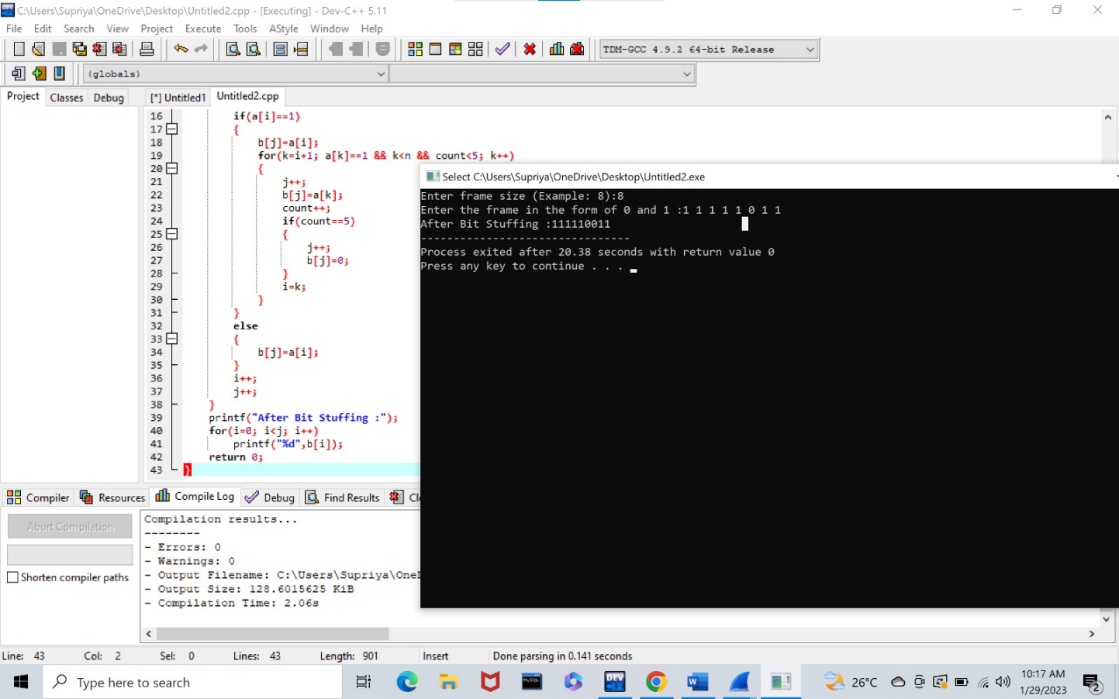

**15.IPV4,IPV6**

